GLA UNIVERSITY

TOPIC: MINI PROJECT SYNOPSIS ON ONLINE VOTING SYSTEM

Submitted By: Submitted To:
Name: Pranjali Jain Faculty Name: Mr. Akash Kumar Choudhary
Id: pranjali.jain_cs20@gla.ac.in Technical Trainer
Name: Yogesh
Id: yogesh.gla_cs20@gla.ac.in

DECLARATION

I hereby declare that the work which is being presented in the Minor Project-II “Online Voting System” in partial fulfillment of the requirements for Project is an authentic record of my own work carried under the supervision of Mr. Akash Kumar Choudhary (Technical Trainer), GLA University, Mathura.
I hereby declare that the submission is my own work and that, to the best of my knowledge and belief. I also confirm that is only prepared for my academic requirement, not for any other purpose. It might not be used in the interest of the opposite party of the corporation.

Sign ______________________ Sign ______________________
Name of Candidate: Pranjali Jain Name of Candidate: Yogesh
University Roll No.:201500501 University Roll No:201500832

ACKNOWLEDGEMENT

On this great occasion of accomplishment of our project on Online Voting System, we would like to sincerely express our gratitude to Mr. Akash Kumar Choudhary (Technical Trainer) who has been supported through the completion of this project.

I am also appreciative to the academic members and specialists in the field who provided insightful input, recommendations, and critiques at various stages of our project. Their feedback has assisted me improving my methods, and broadening my comprehension of the topic matter.

Finally, as one of the team member, I would like to appreciate all my group member for their support and coordination, I hope we will achieve more in our future endeavors.

Name of Candidate: Pranjali Jain Name of Candidate: Yogesh
University Roll No.:201500501 University Roll No:201500832

INDEX

S.NO | Topic
1 | Introduction
2 | System Requirements
3 | Hardware Requirements
4 | Software Requirements
5 | Listing Out Testing Technology
6 | Front End and Back End
7 | Module Description
8 | Availability
9 | DFD 0level 1 level
10 | References

INTRODUCTION: -
The ‘Online Voting System’ is a web-based voting platform for conducting elections online. Our paper deals with online voting system that facilitates user (voter), candidate and administrator (who will be in charge and will verify all the user and information) to participate in online voting and it has a simple and interactive user interface.
This method of voting has gained popularity in recent years as it offers convenience and accessibility to voters who may not be able to participate in traditional in-person voting methods. Online voting is also seen to increase voter turnout, reduce costs and resources required for conducting elections, and improve the accuracy and speed of vote counting.
Despite these challenges, online voting continues to be an important area of research and development as technology continues to advance.

About the Project: -
In this project, we have created an online voting poll in which many participants can apply for the position of head of that year. In this project, there are many options for the students, such as applying to be head of the year or voting for their favorite candidate.
If anyone has any query regarding the work done by the candidate who has applied to be head, then they can drop their queries in the queries section.
Anyone can vote for the student they believe is the best fit for that position by using this website. The head of each year should focus on the students' benefits.
The head of the third year is also the president of the college, and he is responsible for all of the students' tasks each year.

Primary Reason to Choose This Project: -
The primary reason for making this website is to reduce the cost, which would be very high in a physical voting system. By using the online voting process, anyone can vote from anywhere without even going to the place where the vote has to be given, which will reduce the time of the person as well.
Online voting has the ability to overcome these challenges and make the voting process more accessible and convenient for everyone.
Furthermore, the employment of innovative technology in the online voting system can improve the accuracy and efficiency of the process.

The Main Objective of the Project: -
The primary goal of the online voting system project is to provide a secure and dependable platform that can conduct elections over the internet while preserving the accuracy and integrity of the process.
By making voting more accessible and convenient for everyone, the project hopes to enhance voter participation and engagement in the process.
The project's goal is to enhance democracy while also improving the efficiency and cost-effectiveness of election administration.
To increase voter participation and engagement in making voting more accessible and convenient for everyone.
Ultimately, the objective of the project is to improve the efficiency and cost-effectiveness of conducting elections.

Scope Of the Project: -
The project's scope is vast and includes a wide range of tasks, from research and development to testing and implementation. The project team's mission is to create a comprehensive and secure online voting platform that can be utilized in a number of electoral scenarios. This includes defining protocols for data management, voter registration, and vote tabulation, and user interface.
Engagement with stakeholders such as election administrators is also part of the project to ensure that the platform satisfies the highest standards of fairness, and accessibility.
Overall, the project's scope is vast, necessary a multidisciplinary approach to fulfil its goals.

Working Methodology of the Project: -
The project's online voting system working methodology is based on a systematic and collaborative approach that encompasses numerous phases.
The project team initially performs extensive study on the current election system as well as the potential advantages and disadvantages of online voting.
The team then creates a complete plan for the creation and testing of the online voting platform, including major milestones and deliverables. Throughout the development process, the team collaborates extensively with stakeholders to receive feedback and ideas.
The platform is subjected to extensive testing and quality assurance to ensure that it satisfies the highest security and reliability standards.
Finally, the team runs a platform pilot test to evaluate its performance and gain feedback for future enhancements.

Details About the Hardware and the Software System Requirements: -
Depending on the platform being developed, the hardware and software system requirements for an online voting system may differ. In general, hardware requirements may include a stable internet connection, servers for data storage, and voting devices like as laptops, tablets, or smartphones.
To protect the accuracy, privacy, and security of the voting process, the software requirements may include robust security measures, encryption methods, and biometric authentication. Thorough testing and quality assurance are also essential to ensuring that the hardware and software satisfy the highest reliability and performance standards.

Supported Operating system: -
- Windows
- Mac OS
- Linux
- Android

Hardware Requirements: -
- A reliable and secure server infrastructure to store and manage the voting data
- A high-speed internet connection to ensure accessibility and smooth performance of the voting system
- Devices such as laptops, tablets, or smartphones for voters
- Processor – Dual Core
- Hard Disk – 50 GB
- Memory – 1GB RAM
Software Requirements: -
- Xampp
- PHP MyAdmin
- VS Code

For VS Code: -
- A computer with a minimum of 4GB RAM (8GB or more recommended)
- A multi-core processor with a minimum clock speed of 2 GHz
- A fast and reliable internet connection
- Sufficient hard disk space to store the development environment and related files (at least 2GB free space recommended)

Listing Out Testing Technology: -
- Database management systems where the digitalized data is stored and managed
- voter identification and authentication
- vote counting
- Election results

Frontend and Backend: -
The choice of frontend and backend technologies for an online voting system may vary depending on the specific requirements and preferences of the developers. However, some commonly used technologies for frontend and backend development include:

Frontend: -
- HTML, CSS, and JavaScript
- Bootstrap or Material UI for styling

Backend: -
- PHP for server-side development
- MySQL for database management

Module Description: -
- User Module: This module is responsible for user registration, login, and authentication. It also manages user profiles and permissions.
- Admin Module: This module allows the system administrator to manage user accounts, view voting results, and generate reports.
- Voting Module: This module enables the creation and management of voting events, including setting up the voting rules, candidate nomination, and vote counting.
- Reporting Module: This module provides reporting features to analyze the voting results, generate graphs, and export data to other formats.

DFD: -
A data flow diagram (DFD) illustrates how data is processed by a system in terms of inputs and outputs. As its name indicates its focus is on the flow of information, where data comes from, where it goes and how it gets stored.

0 Level DFD: -

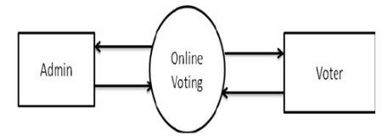

1 Level DFD: -

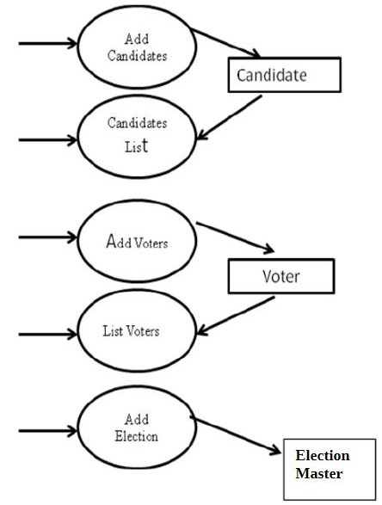

References: -
- www.google.com
- www.stackoverflow.com
- www.chatgpt.com
- www.w3schools.com
- www.php.net
- www.youtube.com
- www.wikipedia.com

